[**Day 7 (04th Feb'22) - Abstraction**](https://learnifyme.ialabs.co.in/course/view.php?id=19#section-7)

**Khushi Agrawal**

**Java batch 1**

**Session1**

1. Create a class Beverages, the Tea and Coffee sub classes are using the common method addMilk and they are implementing abstract method void addIngredient.

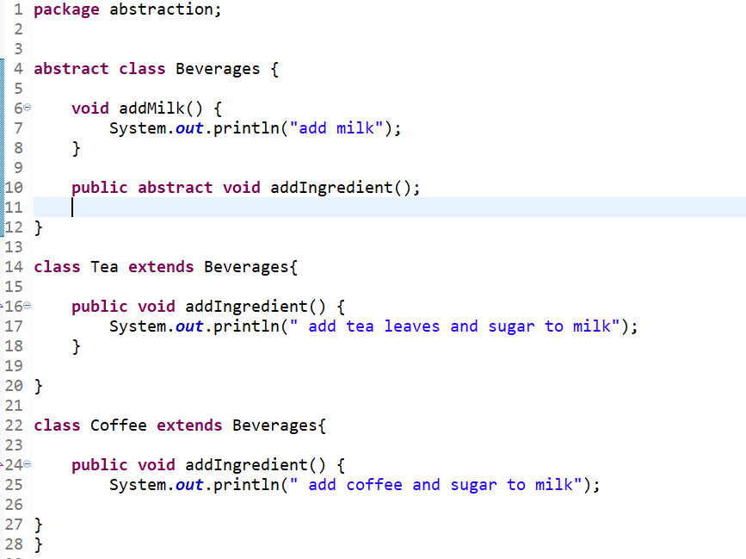

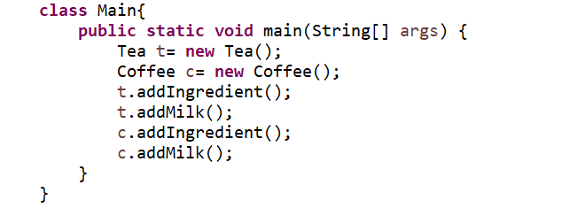

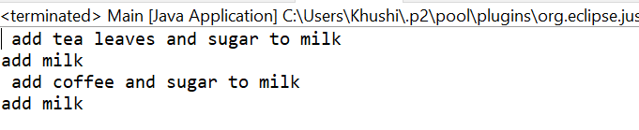

1. Create an Array of Employee class and initialize array elements with different employee objects.

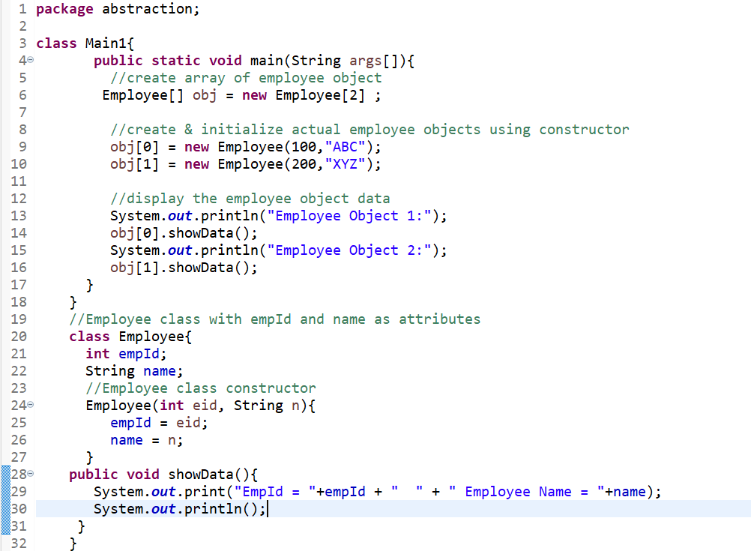

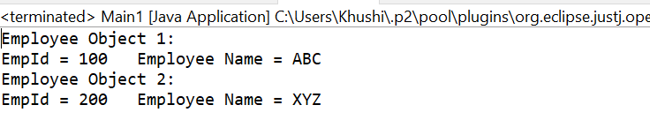

**SESSION 2**

1. create a class ProtectedClass under a package pack1 in which we declare a protected method show(), create a class ProtectedAccess under a package mypack1 and import a package pack1.

**Package 1**

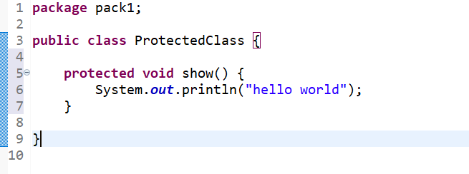

**Package2**

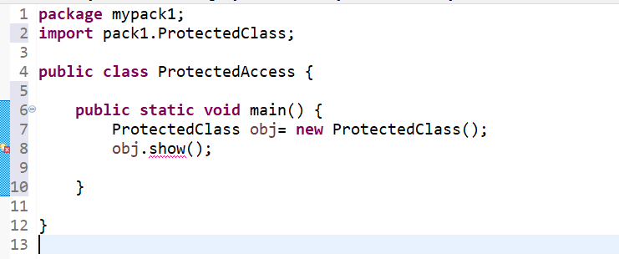

**Output : Compile time error**

2. Implementing Accessibility of members across packages and classes

1.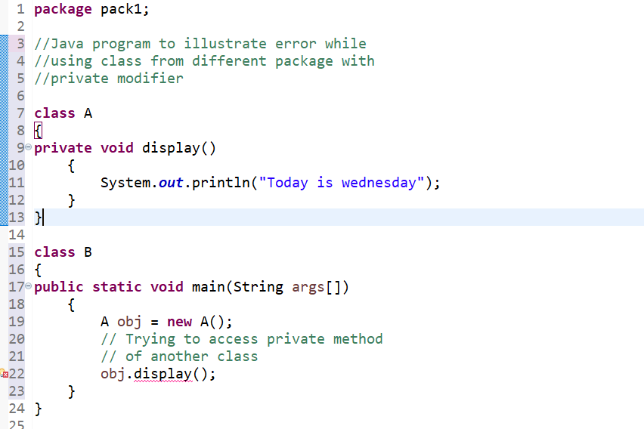

Output : compile time error